

Junior

**Dumb Potatoes**

**Team**



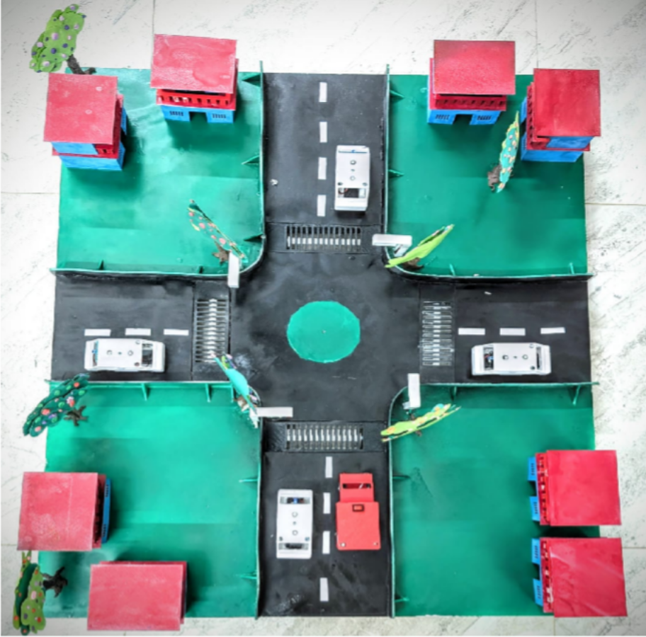 Bangladesh

Table of Contents

Presenting our Team 4

Abstract 5

Problem Statement 5

Reason for Choosing this Problem 6

Robotic Solutions 7

Key Features 7

Value of our Solution and Real-Life Implementations 8

Limitations 9

Components 9

ESP32: 9

Li – ion Battery: 9

LDR: 9

Boost Module – HW-085: 9

Buzzer: 10

Servo Motor – SG90: 10

Resistor: 10

Voltage Regulator – AMS1117: 10

LED: 10

Capacitor: 10

Flow Chart 11

Circuit Diagram 12

Code 13

Challenges Faced 16

Problems Faced 16

Solution 16

Social Implementation 16

Cost of the Prototype[3] 18

Business Lean Canvas 19

Availability of Similar Content 20

References: 21

# Presenting our Team



“Quieter Streets, Safer Transport”

# Abstract

Some of the world’s busiest cities are infamous for their extreme traffic congestion and disorderly road behavior. Narrow lanes, unregulated parking, and dense flows of rickshaws and vendors routinely block emergency vehicles, even when sirens are on costing lives that could be saved with timely care. To tackle this urgent issue, we team, “[**Dumb Potatoes**](https://www.facebook.com/share/1729gwY34Z/)” tried to develop a **Smart Traffic Infrastructure** aiming to achieve noise pollution free road by introducing **“Silent Horn”** and **“In-Vehicle Emergency Alert System”** that will notify the other drivers in the vicinity to make a way for the ambulances and the fire brigade. To support this eco-system, we have developed an **“Priority Based Adaptive Traffic Control System”** that gives real-time signal priority to emergency vehicles and uses features like retractable mechanical spikes to clear heavier lanes when needed. By dynamically adjusting traffic flow and creating clear corridors, our system aims to reduce emergency vehicle (ambulance and fire-truck) delays, speed up response times, and make our roads safer and more responsive during emergencies.

# Problem Statement

Urban traffic congestion is an issue in many cities around Dhaka, causing severe delays in emergency response and daily communications. Throughout peak hours and holiday seasons, urgent-service vehicles frequently become stuck in traffic, delaying critically time-sensitive care.

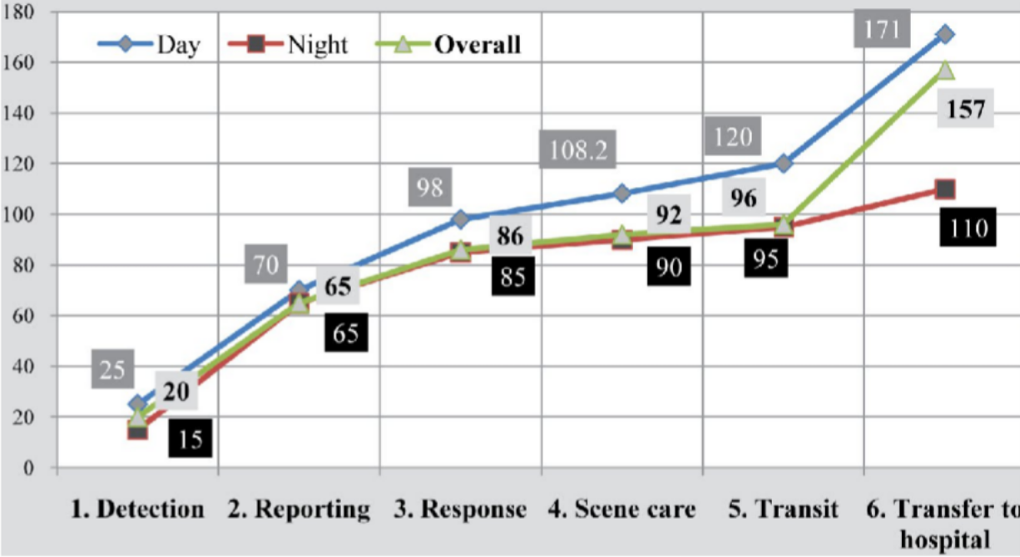

These conditions make it challenging to accurately assess situations, and our team tried to identify the crippling need for an even more monitored system developed to reduce human labor. The key factors we tried to focus on are:

* Fixed signal timing that fails to adapt to real-time traffic volume or priority vehicles.
* Ambulance services struggle due to congested intersections, reducing survival rates drastically.
* Road users and pedestrians face elevated risk from unpredictable driver behavior when traffic signals are ignored.
* Hawkers and vendors on highways, making drivers more accident prone.
* Lack of enforcement mechanisms to physically reduce illegal road entry.
* Unregulated roadside parking, narrowing lanes.
* Low awareness signaling, excessive honking contributes to chaos and noise pollution.

# Reason for Choosing this Problem

In Dhaka, nearly **1,000 ambulances** are on the road every day, transporting about **700 critically ill patients[1].** Severe traffic congestion turns rescue missions into tragic delays. An ambulance travels for 85 minutes, and daytime **delays** normally reach up to **102 minutes**. *In emergencies,* ***every second matters****, and rapid response can be the difference between life and death.* As a result, **56% of emergency patients** arrive more than one hour after calling for help**,** and experts estimate that approximately **195 lives** could be saved each day if ambulances had reached on time **[2].** These prolonged journeys don’t just waste time, they cost lives.

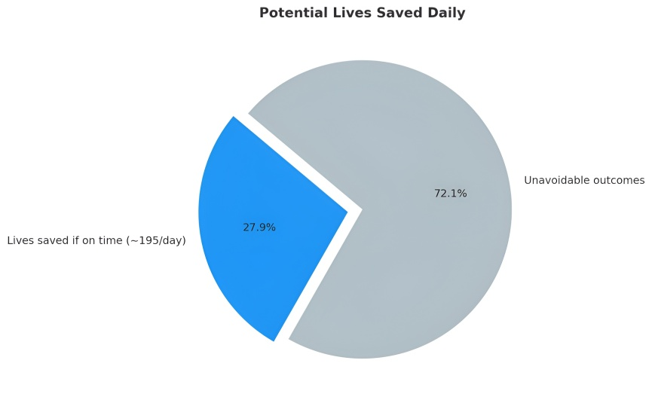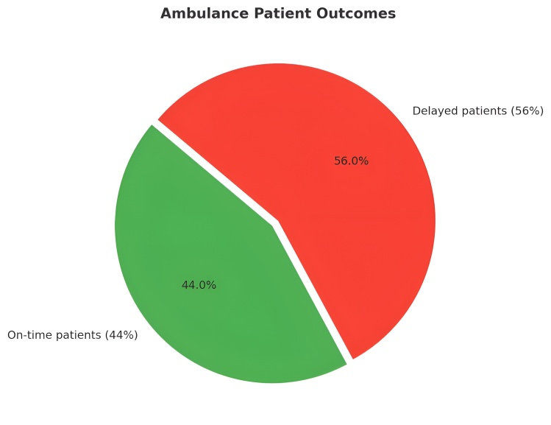8b

The loss of a loved one makes a devastating impact on family lives. That means each year, tens of thousands of lives hang in the balance; caught in between the chaos of gridlocked roads and the promise of immediate care. Our goal isn’t to just improve traffic flow, it is to ensure that those precious minutes are won back and critical patients reach help before it’s too late. That’s why we chose to work on traffic congestions.

# Robotic Solutions

Our traffic control system is designed to ensure a safe and sustainable environment, regulating noise and reducing the dependency on human labor. Cameras measure the density of vehicles on every lane. Traffic signals change their intervals based on readings. If any emergency vehicle is detected, the system creates a clearing of the lane for the vehicle to pass through within a short time. Equipped with a retractable spike mechanism by servo motors, rule violation has immediate consequences and noted on a spreadsheet during entry and exit of a vehicle and an amount is calculated to be deducted ensuring payment without human interference.

# Key Features

* Our system runs depending on the present situation and do not rely on regular traffic intervals. This system reduces the need for human interference, and limits need for human labor. The system is fully automated and relies on ongoing vehicles and situations.
* 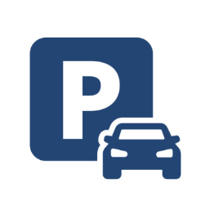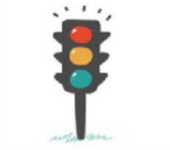It is equipped with a web camera that captures real-time video, counting the number of vehicles per lane. The system then adjusts green light duration based on density of vehicles, keeping traffic flowing smoothly even in peak hours. The system autonomously manages intersections by processing live traffic camera and sensor data directly at each intersection.
* . If a vehicle doesn't move a certain distance in a certain time even when its green light is on their side, the system will detect the ID of the vehicle, count its parking duration and send its ID and parking duration to a Google spreadsheet.
* The system detects approaching ambulances and clears a path by switching signals ahead of them, ensuring they don’t get stuck in traffic and can reach destinations faster. This allows emergency vehicles to navigate through traffic without delays, reducing response times.
* 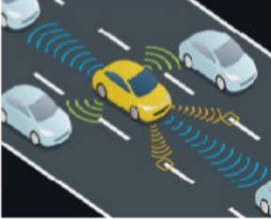Drivers press a button to send real-time alerts via ESP-NOW. The nearby cars instantly flash LED lights instead of honking, reducing noise and improving communication with minimal delay. The system uses ESP-NOW protocol, peer-to-peer communication method allowing devices to communicate directly ensuring efficient and real-time data exchange between vehicles.
* 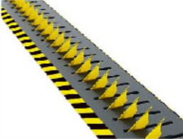If any vehicle violates any traffic rules, an automated spike mechanism will be activated to keep the vehicle in place. This ensures the rules to be followed and the consequences be delivered.

# Value of our Solution and Real-Life Implementations

Our comprehensive traffic-control system features adaptive signal control**,** emergency vehicle preemption**,** mechanical spike enforcement**,** and RFID-based parking management delivering measurable improvements in safety, efficiency, and emergency response; which, if implemented accordingly can assist in:

* Fast response times for emergency vehicles.

◦`Reduced congestion and travel time.

* Efficient and smart parking control.
* Immediate rule enforcement.
* Easy communication.
* Reduced reliance on human labor.

If an ambulance approaching an intersection during rush hour, the system instantly detects its presence via cameras, halts all conflicting traffic, and displays a direct green signal for swift passage. Our solution replaces noisy horn signals with LED- based alerts**,** transforming vehicle communication silent and smooth. RFID-based parking eliminates the need for attendants at entry and exit booths, minimizing manual ticketing and cash handling. Similarly, automated spike deployment and adaptive traffic signals replace on-the-ground traffic controllers who typically direct or enforce rules. This means cities can reallocate personnel from mundane monitoring and focus on higher-value roles like incident response, public outreach and maintenance.

# Limitations

* Our system doesn’t detect people walking or biking near intersections.
* Vehicles cannot detect the direction the horn is coming from.

# Components

## ESP32:

ESP32 is a low-cost, low-power system on a chip- microcontroller with integrated Wi-Fi and dual-mode Bluetooth. It is a microcontroller that can be programmed and be used for specific tasks. The **ESP32** serves as the **main microcontroller** for each vehicle, enabling our **sound-free horn system** and coordinating real-time traffic communication using **ESP-NOW communication system.**

## Li – ion Battery:

Li-ion batteries are a type of rechargeable battery that uses lithium ions to store and release energy. This works as the power supply of our system. We chose this as it is affordable and enables to store more energy for extended periods without significant capacity loss, benefitting our system.

## LDR:

LDR – Light Detecting Resistor is a type of electronic component whose resistance changes with light intensity. It is a passive electronic component that detects light in its environment.

## Boost Module – HW-085:

The HW085 is a voltage regulator that helps adjust and maintain a stable output voltage from a lower input voltage to a higher output voltage. The mini boost converter is converting the lower input voltage to a higher, stable output voltage before distributing it to the other devices**.**

## Buzzer:

The buzzer is a sounding device that can convert audio signals into sound signals. It works as an indicator for vehicles to move aside if they are in the way of other vehicles or transport.

## Servo Motor – SG90:

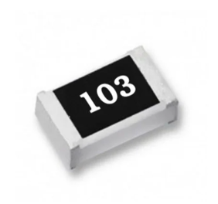A servo motor is a rotary actuator allowing precise control of angular or linear position, velocity, and acceleration. The servo motor controls the direction of the spike after getting signal from the microcontroller. The reason of choosing it is because it can precisely control the position of the ESP32 Cam by rotating it to a specific angle.

## Resistor:

A resistor is an electrical component that limits the flow of electrical current in a circuit by converting electrical energy into heat. Resistors are used to control and protect sensitive parts of a circuit.

## Voltage Regulator – AMS1117:

The AMS1117 is a low-dropout voltage regulator IC used to provide a stable direct current (DC) output voltage, typically from a higher input voltage, for electronic circuits.

## LED:

LED (Light Emitting Diode), is a small, energy-efficient light source that produces light when an electrical current passes through it. It is used in traffic lights and as the headlights of vehicles. When an emergency vehicle approaches, it sends a signal via ESP-NOW, causing nearby cars to flash an LED beside the driver’s seat as a silent visual alert.

## Capacitor:

A capacitor is an electronic component that stores electrical energy by holding electric charges on two separate, conductive plates. It is a tiny, rechargeable battery that stores a small amount of charge and can discharge it very quickly.

# Flow Chart

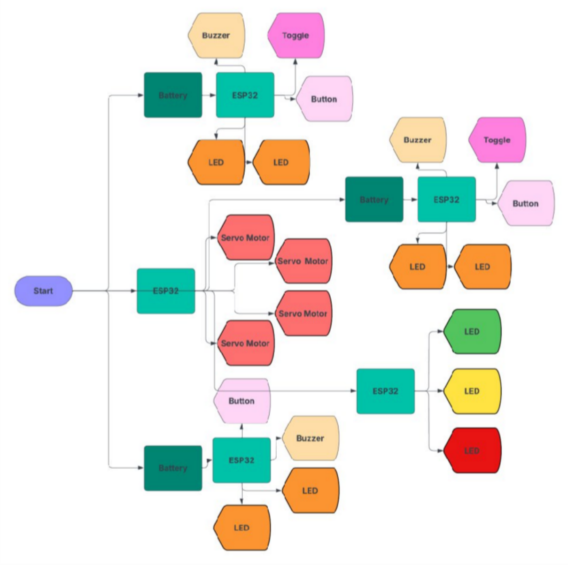

# Circuit Diagram

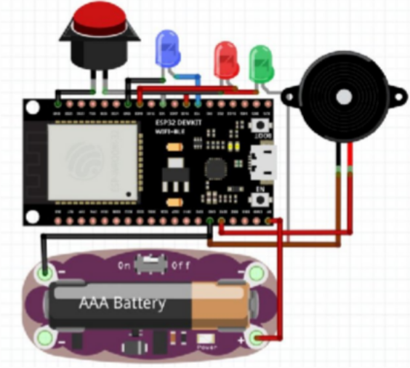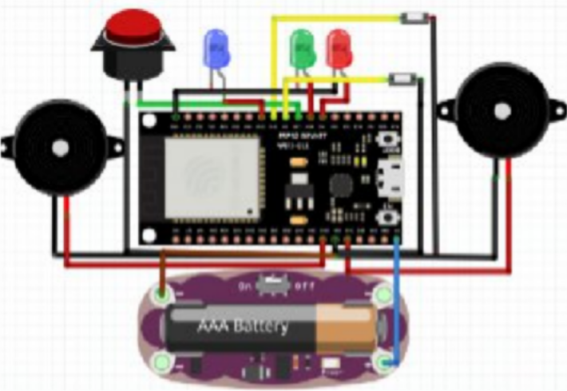

**Ambulance Circuit Car Circuit**

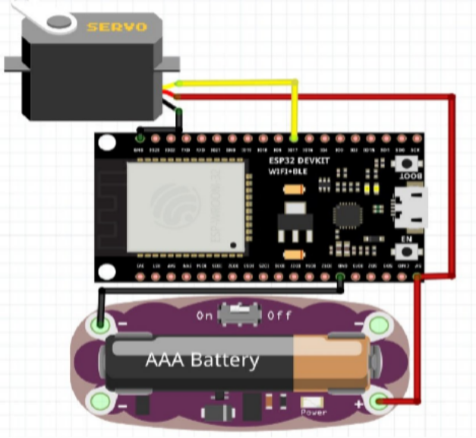

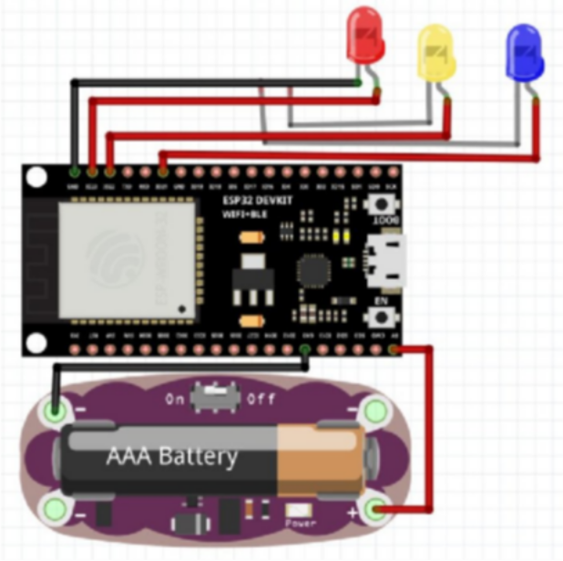

**Spike Circuit Traffic Light Circuit**

# Code

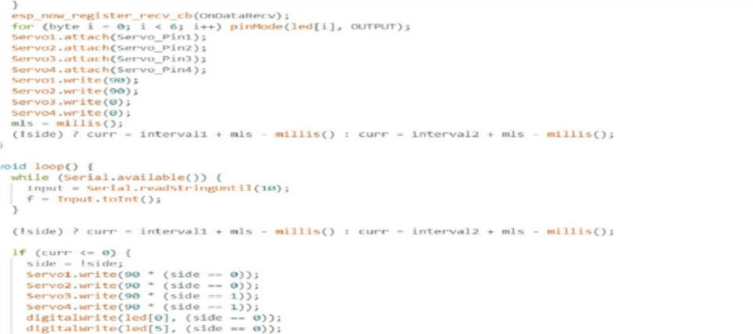

It sets up ESP-NOW for wireless communication as it needs to receive the button status of the emergency vehicles to send it to python so that python can send readings to port based on the emergency vehicle’s button status. There are 4 servos attached to pins 19,22,23,15 which will be used to control the spikes. The LEDs are on pins 13,17,4,27,16,18 which will be used for the traffic lights.

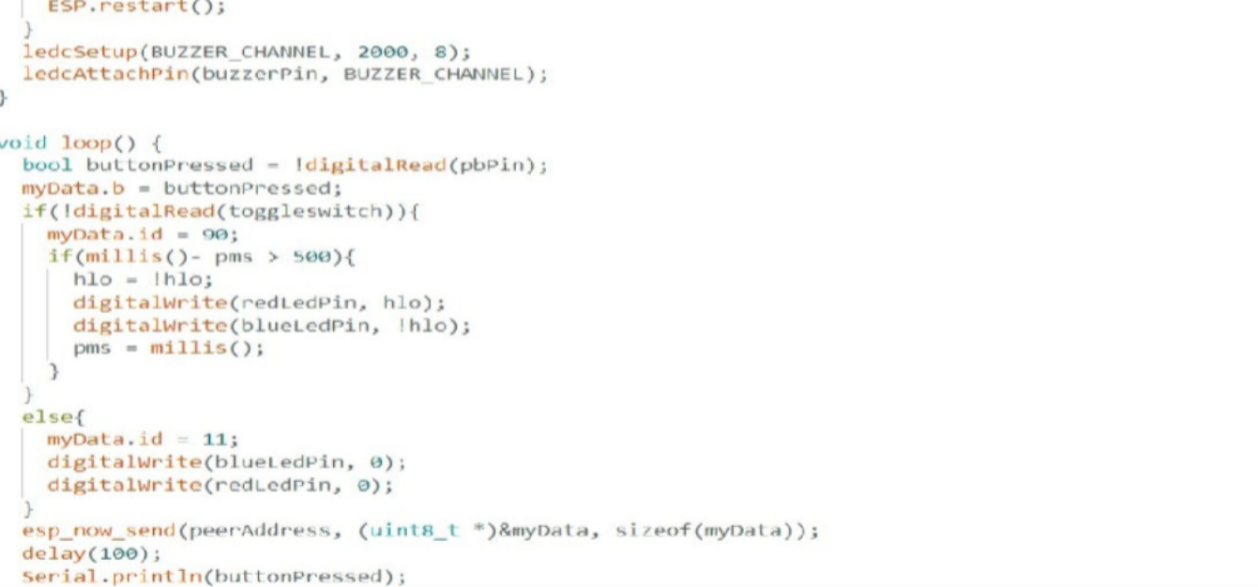

It sends signals using ESP-NOW receiving both emergency signals and handles them differently. For normal signals where the button status is pressed, it turns on its buzzer, and the tone depends on the number of vehicles in its range. For emergency signals where the button status is pressed, if it is the first time the vehicle is sending the signal, it plays a special alarm and turns on an LED. For subsequent signals from the same vehicle, it only turns on the LED.

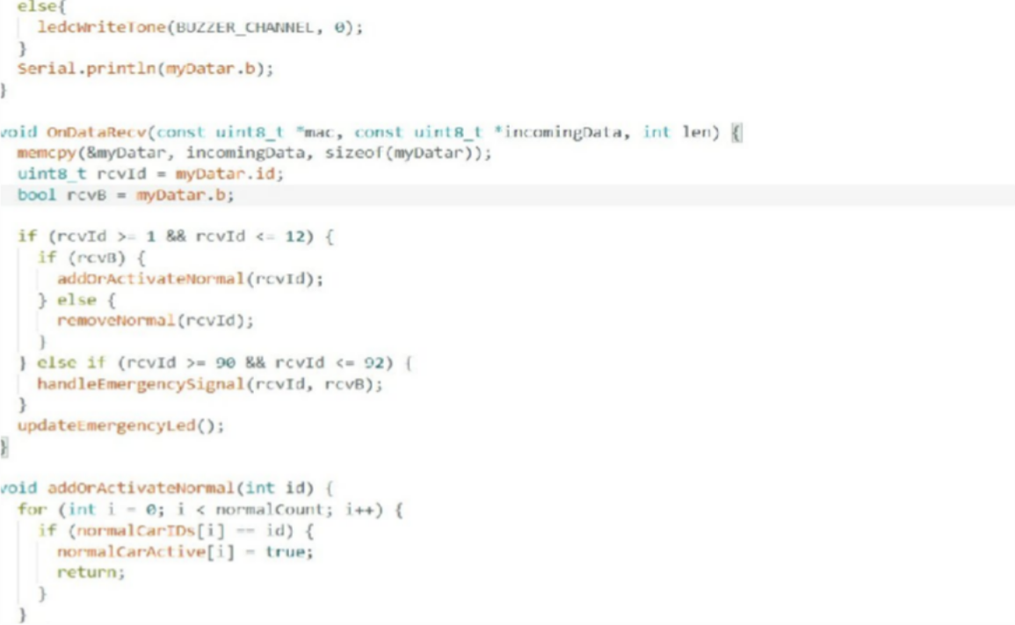

The code sends a normal signal every 100 milliseconds using ESP-NOW. It also receives both normal and emergency signals and handles them differently. For normal signals where the button status is pressed, it turns on its buzzer, and the tone depends on the number of vehicles in its range. For emergency signals where the button status is pressed, if it is the first time the vehicle is sending the signal, it plays a special alarm and turns on an LED. For subsequent signals from the same vehicle, it only turns on the LED.

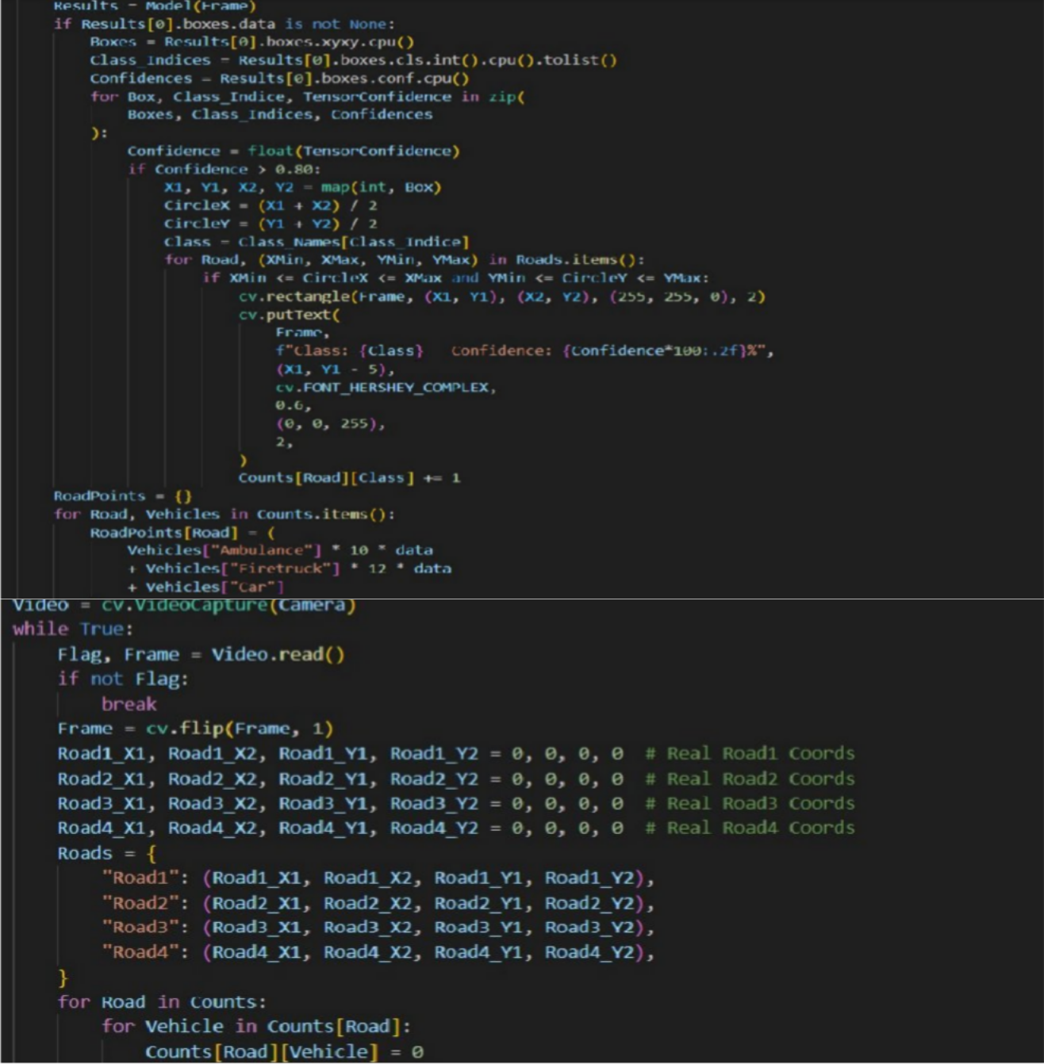

A Python Code to Send Importance Disparity Between the Two Roads to the Port. This code reads the number of each class of vehicles present on each road (Car, Ambulance) and multiplies them by predefined weights. The urgency of a vehicle determines its weight. Then it calculates the disparity between the two main roads and sends it to the port, where it is used to determine the traffic light’s

changing interval.

# Challenges Faced

|  |  |
| --- | --- |
| Problems Faced | Solution |
| Taking the pictures for model training was taking too much time. | Running a python script that saves the frames per 0.1 second and save them. |
| Figuring out the flow and norms of traffic. | Researched about traffic congestions and reasons for traffic congestions. |
| As we used THTcomponents initially, our circuit as well as 3D designed vehicles were larger in size. | We had to improve the circuit by using SMD components and re-design in respect of our model. |
| We were facing problems in soldering SMD components. | We tool help from our coach and learned how to solder the components, then tried again. |
| Bad real time performance of detection of vehicles. | Adding multi-class present pictures, increasing training data and training epochs. |

# Social Implementation

Smart Traffic Infrastructure System is designed to ensure a safe and sustainable environment, regulating noise and reducing the dependency on human labor. This reduces the need for manual labor, assisting traffic workers immensely helping to reach critical patients in time, almost saving them from the brink of death.

* Better Urban Livability Due To Noise & Pollution Control.
* Reduced Traffic Congestion & Lower Emissions.
* Enhanced Emergency Response.
* Improved Road Safety & Accident Reduction.
* Minimized Need for Manual Labor.
* Enhances Community Well Being.

Through this system, we can achieve smoother traffic flow with reduced congestion, cutting travel times for a cleaner, quieter city. This reduces noise pollution by replacing horns with visual alerts, receiving first priority, making urban spaces more livable. Emergency vehicles gain faster passage ensuring timely medical and rescue responses. Automation reduces the need for manual traffic control and the smart parking management minimizes the time drivers spend searching for spots, reducing stress and fuel waste. Safer intersections and adaptive control help lower accident rates, protecting both drivers and pedestrians.

It promotes social equity by improving access to reliable transport across communities and supports public health by encouraging safer, more active, and environmentally friendly urban lifestyles.

# Cost of the Prototype[3]

|  |  |  |  |
| --- | --- | --- | --- |
| Component | Quantity | Individual Cost | Total Cost |
| ESP 32 | **8** | **3.68$** | **29.44$** |
| Voltage Regulator | **7** | **0.11$** | **0.77$** |
| Servo Motor | **4** | **1.11$** | **4.44$** |
| Switch | **7** | **0.70$** | **4.90$** |
| Button | **14** | **0.041$** | **0.57$** |
| SMD LED | **7** | **0.082$** | **0.57$** |
| LED | **14** | **0.082$** | **1.14$** |
| Boost | **7** | **0.53$** | **3.71$** |
| Charging Module | **7** | **0.25$** | **1.75$** |
| Battery | **7** | **1.57$** | **10.99** |
| SMD Capacitor | **28** | **0.082$** | **2.29$** |
| SMD Resistor | **28** | **0.082$** | **2.29$** |
| SMD Buzzer | **7** | **0.41$** | **2.87$** |
| Others |  |  | **35$** |
| Total |  |  | **100.73$** |

# Business Lean Canvas

# Availability of Similar Content

Through our research, we found various similar systems designed to address specific challenges in traffic control. Some of them include systems like:

*In Bangladesh:*

* ITMIDS(Integrated Traffic Management and Incident Detection System)[4]

ITMIDS is a smart traffic control and monitoring system planned for Bangladesh’s highways. It uses technologies like **CCTV cameras, Automatic Number Plate Recognition (ANPR), speed detectors, and real-time traffic sensors** to monitor vehicle flow, detect accidents or traffic violations, and quickly alert authorities. The goal of ITMIDS is to reduce congestion, improve road safety, and ensure faster emergency response on busy highway corridors.

* Traffic Management Center (TMC)[5]

The TMC in Bangladesh is a central control facility that monitors and manages highway traffic using **Intelligent Transport Systems (ITS).** It is equipped with CCTV, sensors, and communication tools, and helps detect congestion, accidents, and violations in real time, enabling quicker responses and improving overall road safety and traffic flow.

*Other Countries:*

* SURTAC(Scalable Urban Traffic Control) in Pittsburg, United States[6]

The SURTAC system is an advanced traffic management solution that adjusts traffic light timings in real-time based on actual road conditions. Instead of relying on fixed intervals, it uses sensors and cameras to monitor vehicle flow and density at intersections. The system then analyzes this data and automatically allocates longer green signals to lanes with heavier traffic while reducing waiting times for less congested roads. By adapting to current traffic situations, SURTAC helps minimize congestion, improve road efficiency, reduce fuel consumption, and ensure smoother traffic movement in busy urban areas.

* SCATS(Sydney Coordinated Adaptive Traffic System) in Sydney, Australia**[7]**

The SCATS is a smart traffic control system that uses real-time data from road sensors to adjust signal timings dynamically. By coordinating multiple intersections, it reduces congestion, improves travel time, saves fuel, and adapts to changing traffic patterns throughout the day.

* SCOOT(Split Cycle Offset Optimization Technique) in United Kingdom[8]

The SCOOT system is an adaptive traffic control method that manages signals in real-time using data from detectors on the roads. It continuously measures traffic flow, queue lengths, and congestion, then adjusts the duration and coordination of green lights to keep vehicles moving smoothly. Unlike fixed systems, SCOOT responds instantly to changing conditions, helping reduce delays, improve travel times, and minimize stops across a network of intersections.

The above systems focus on live traffic signals and ensures that emergency vehicles reach their destinations on time. However, their functionalities often fall short of addressing rule benders and maintaining a less chaotic environment.

Our innovation, **Smart Traffic Infrastructure**, sets a new standard by seamlessly integrating multiple functionalities into one advanced system. Not only does it gather real-time data of vehicles, but it also delivers an immediate consequence and maintains a sound free environment. Additionally, our system enables to collect a specific amount for parking depending on the duration of stay.

Furthermore, a smooth and silent communication between vehicles is established, eliminating the need for blaring horns. All this ensure a safe driving experience as well as plays and efficient role in improving our surroundings.

# References:

**[1]**

[**https://www.tbsnews.net/features/panorama/amidst-all-development-how-about-lane-ambulances-714214?**](https://www.tbsnews.net/features/panorama/amidst-all-development-how-about-lane-ambulances-714214?)

**[2]** [**https://clinmedjournals.org/articles/ijccem/international-journal-of-critical-care-and-emergency-medicine-ijccem-8-138.php?jid=ijccem&**](https://clinmedjournals.org/articles/ijccem/international-journal-of-critical-care-and-emergency-medicine-ijccem-8-138.php?jid=ijccem&)

**[3]**

[**https://www.electronics.com.bd/**](https://www.electronics.com.bd/)

**[4]**

[**https://en.people.cn/n3/2023/0131/c90000-10201248.html?**](https://en.people.cn/n3/2023/0131/c90000-10201248.html?)

**[5]**

[**https://www.thedailystar.net/news/bangladesh/transport/news/bangladeshs-first-traffic-management-center-launched-improve-highway-safety-3967801?**](https://www.thedailystar.net/news/bangladesh/transport/news/bangladeshs-first-traffic-management-center-launched-improve-highway-safety-3967801?)

**[6]**

[**https://en.wikipedia.org/wiki/ScalableUrbanTrafficControl?**](https://en.wikipedia.org/wiki/ScalableUrbanTrafficControl?)

**[7]**

[**https://en.wikipedia.org/wiki/Sydney_Coordinated_Adaptive_Traffic_System**](https://en.wikipedia.org/wiki/Sydney_Coordinated_Adaptive_Traffic_System)

**[8]**

[**https://en.wikipedia.org/wiki/Split_Cycle_Offset_Optimisation_Technique**](https://en.wikipedia.org/wiki/Split_Cycle_Offset_Optimisation_Technique)